DAVID JON KASSAN WORKSHOP
MAY 21, 2016, 10am-5pm at the Greenwich Garden Education Center,
130 Bible Street , Cos Cob 06807
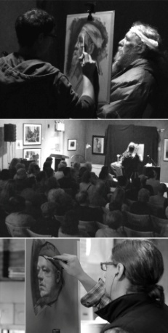
As part of CSOPA's special events relating to Tribute to Mothers ~ Springtime Portrait Exhibition, internationally acclaimed artist and teacher,David Jon Kassancomes to Greenwich forone day only. See him demonstrate portrait painting from live model using his patented Parallel Palette.
Attendees are welcome to paint along with David. Bring your own easel and supplies plus drop cloth to protect GEC floor.
His work and materials list can be found on www.davidkassan.com.
Professional artists, art students, teachers, press and collectors are all welcome. CSOPA membership is not required. Questions? Contact: csocietyopa@aol.com.
Space is limited and sell-out is expected. Online PayPal registrations preferred. Or, you may complete the form below and mail your check to CSOPA.
Prepare to be amazed!
========================CLIP AND MAIL============================
DAVID JON KASSAN WORKSHOP REGISTRATION
Your Name: _____________________________________________________________
Your Email: _______________________________________
Cell Phone: _______________________________________
Check One: ___ I plan to observe only. ___I plan to sketch. ___I plan to paint.
Check one: ___ I want a Full Lunch (Add $15) ___I want a Salad Only (Add $7) Full lunch includes several sandwich or salad choices, chips, apple, beverage. Salad only option is just that - a garden salad with your choice of dressing. Those who have prepaid lunch will have the opportunity to order the morning of demo.
Registration: $150 __________
Lunch: $15 (Full) or $7 (Salad only) __________
Total: $__________
Mail your form and check payable to "CSOPA" to: CSOPA Treasurer, Francis Philibert, 56 White Oak Dr., Prospect, CT 06712

