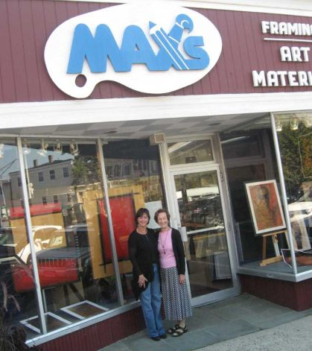

Call for Entries
CSOPA artists will be featured in the front window exhibition space of Max’s Art Supplies in Westport, CT. Max’s has a longstanding tradition of giving back to the community that supports them by offering monthly exhibits of the work of the many famous artists and illustrators whose needs they have served over many decades of operation in town. It is considered an honor by local artists to be offered a month in the windows, and provides excellent exposure to heavy foot traffic in the downtown area.
Works will be juried by a CSOPA selection committee, but not judged for awards. Open to all members of the Connecticut Society of Portrait Artists able to deliver and pick-up selected entries to Max’s Art Supplies during specified dates and times may submit.
Works Eligible
Original portrait paintings, drawings and sculptures by CSOPA members and completed within the past three years are eligible. Note: you must have a current, active membership or honorary membership in order to submit. Works may have been previously submitted to and/or selected for CSOPA exhibitions. No giclee, canvas transfers, photographs or computer images. Paintings must be framed and wired for hanging with size limit 36” vertically, 24" maximum horizontally, including frame. Sculpture limited to 75 lbs and pedestals must be provided. Artwork must be available for the duration of the exhibition (February 1st through February 28th, 2013).
Submission Deadline and Procedure
Artists must submit entry forms, images and payment by December 31st, 2012.
Entry Form, Check and Labels
Complete Max’s Showcase Artist’s Submission Form, clip, and mail with check (made payable to CSOPA) to: CSOPA c/o Frances Philibert, 56 White Oak Drive, Prospect, CT 06712. Entry form and payment must be postmarked by midnight December 31, 2012. Submissions without completed entry form and payment will not be considered. Do not mail photographs, slides, CDs or DVDs of images, follow the instructions below to email JPEGs of image(s).
Email JPEG Image(s)
Email JPEGs of image(s) to CSOPAentry@gmail.com. JPEGs must be received by December 31st. Images must be emailed and in digital jpeg format only, with resolution of at least 300 dpi. Images must be a minimum of 2,000 pixels vertically. Please make all JPEGS proportional to the original’s dimensions. Subject line should read “Showcase-YourLastName.” Name each image attachment “YourLastName/PortraitTitle.” Please include the information below in the body of the email:
o Artist name
o Artist contact information (email, home telephone, cell phone and address)
o For each image: full title, height, width, medium, date completed and price. If not for sale please indicate “NFS” and price for similar (required for insurance purposes).
Your effort to follow the electronic submissions specifications ensures the most advantageous representation of your work and allows CSOPA to make quality selections. Have questions regarding digital submissions? Email CSOPAentry@gmail.com or call Michel Delafontaine at (914) 319-4059 for technical help. Submission does not guarantee selection by CSOPA for the exhibit. Substitutions and late entries will not be accepted.
Notification
Selected artists will be notified by email by January 14th, 2013.
Receiving for Selected Artists
Drop off is Thursday, January 31st, 9am to 5pm and Friday, February 1st, 9am-12pm, at Max’s Art Supplies, 68 Post Road East, Westport, CT. Nina Royce, of Max’s, will be in charge of receiving and hanging the show. If there is not a CSOPA representative present at the time you arrive, please ask for her and sign in.
Removal
All art must be picked up on Thursday, February 28th, between 9am and 5pm. Neither CSOPA nor Max’s will be held responsible for loss or damage to artwork from time of delivery until pickup. Agents for you may pick up only with your written authorization. A $10/day storage fee will be charged for any work not picked up on 2/28, and arrangements must be made with Jeanine Jackson, jacksonportraits@aol.com. Late pick up will be at 3 Westcott Ct., Riverside, CT.
Sales
There is no gallery fee. 20% voluntary contribution to CSOPA for any work sold or commissions received through February 1, 2014 as a result of this show should be mailed to Francis Philibert, address above.

CSOPA Max’s Art Supplies Showcase Artist’s Submission Form
Please complete this form and mail to: CSOPA c/o Frances Philibert, 56 White Oak Drive, Prospect, CT 06712
(all contact information fields required)
Artist’s Full Name
Street Address; Town, State, Zip
______________________________________________________________________________
Phone_____________________ Email_______________________________________________________________________
First 2 Showcase Exhibition Entries @ $20 $____________
All Additional Submissions (max 4 entries total) @ $10 each $____________
Active CSOPA Membership is required. Renew/Check Status Link: http://www.csopa.camp8.org.
or Renew your CSOPA membership now @ $40 $____________
CSOPA is a 501 (c) 3 nonProfit Arts Education organization.

Total Amount Enclosed for Entries $____________
Make check payable to “CSOPA”
Liability
CSOPA, Max’s Art Supplies and their agents cannot be held responsible for loss or damage to artwork however caused. Your entry to this exhibition constitutes your agreement with these terms and conditions. I hereby agree to the liability clause and to abide by the rules of this prospectus for the CSOPA Max’s Showcase exhibit.
Artist’s Signature____________________________________ Date_________________________
Optional Release: I hereby give CSOPA or its assigns permission to use my submitted artwork and my name for promotional purposes and to post my artwork on the CSOPA website.
Artist’s Signature_____________________________________ Date_________________________

