PRESS RELEASE for Immediate Release May 29, 2020
Attention: Events, Story Editor, Community News
Subject: Faces of Pandemic Front Lines presented by The Connecticut Society of Portrait Artists (CSOPA) in collaboration with Stamford Downtown
Online Gallery - Now, Virtual Reception - June 14, 3pm; Storefront Display - beginning June 19, at 170 Bedford Street, Stamford, CT
Official Website: www.csopa.org/heroes.html
Contact: Jeanine C. Jackson, Founder and President, CSOPA
3 Wescott Court, Riverside (Greenwich), CT 06878
203-856-4713 CSocietyOPA@aol.com

A sampling of images (below and attached) provided with artists' permission for publication

=====================================================================================

The Connecticut Society of Portrait Artists (CSOPA), a Greenwich-based arts non-profit, responds to the impact of social isolation on artists by having members create a portrait of someone they know who is working on the front lines during COVID19. The result is a telling mix of healthcare professionals and providers of essential services who will receive their portraits as "Thank You" gifts.

Professional members of (CSOPA) working in and around the state honor their heroes during the month of June with both a virtual and a storefront exhibition titled Faces of Pandemic Front Lines (FPFL). Details can be found on the website: www.csopa.org/heroes.html.

Online Gallery - Now; Virtual Reception - June 14, 3pm; Storefront Display - begins June 19, at 170 Bedford Street, Stamford, CT in collaboration with Stamford Downtown.

Artists/Heroes include: Linda Champanier/Evelyn Akin Dahm. Joyce Zeller Endick/Nurse Genevieve Anne Puppel, Cynthia Gillette/Husband Firefighter Earl Gillette, Colleen Hains/Pharmacist Stephanie, Jeanine Careri Jackson/Nurse Kerri Conklin Burghart, Shawna Lee Kwashnak/Grocer Joe Dinova, Christine McBryan/Nurse, Nancy Malkin Stember/Peter Stahl, MD, Wing Na Wong and more...

The Online Gallery features portraits as they are completed with something about each hero who inspired their artist. The Virtual Reception on June 14, 3pm has free registration and is open to the public. It will included artists as well as heroes. With sponsorship from Stamford Downtown, the FPFL Storefront Display will be unveiled at 170 Bedford Street, Stamford, CT on June 19. "That's the day we were supposed to participate in Stamford's annual ArtWalk that has been canceled due to the pandemic," explains CSOPA Founder and President Jeanine Jackson. "We created something that speaks to this unique time in history and can be viewed safely through the store window as well as online."
Details can be found on the website: www.csopa.org/heroes.html.

​

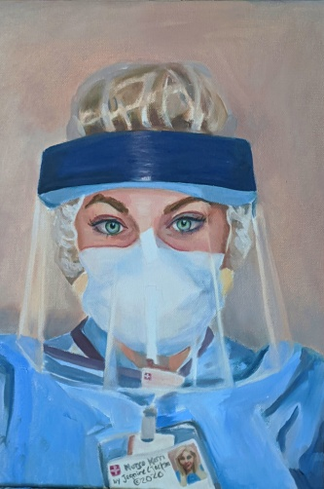
Nurse Kerri by Jeanine Careri Jackson

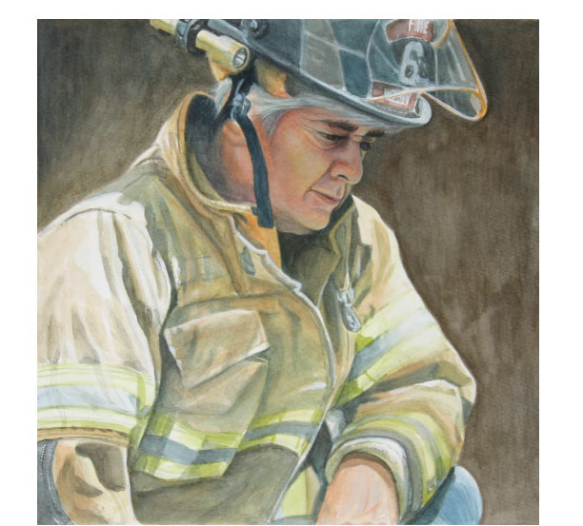
Firefighter Earl Gillette by Cynthia Gillette

​
​
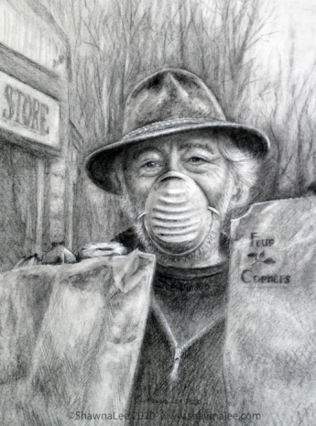
Grocer Joe Dinova by Shawna Lee Kwashnak
​
​

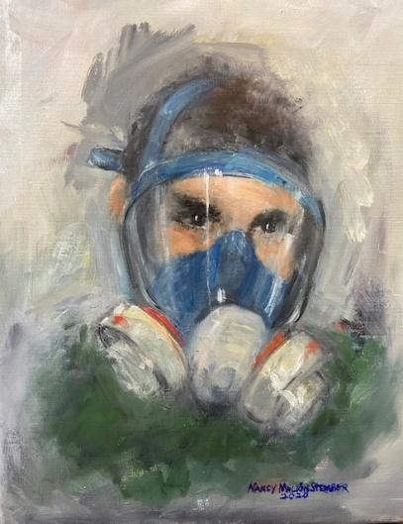
Peter Stahl, MD by Nancy Malkin Stember
​

