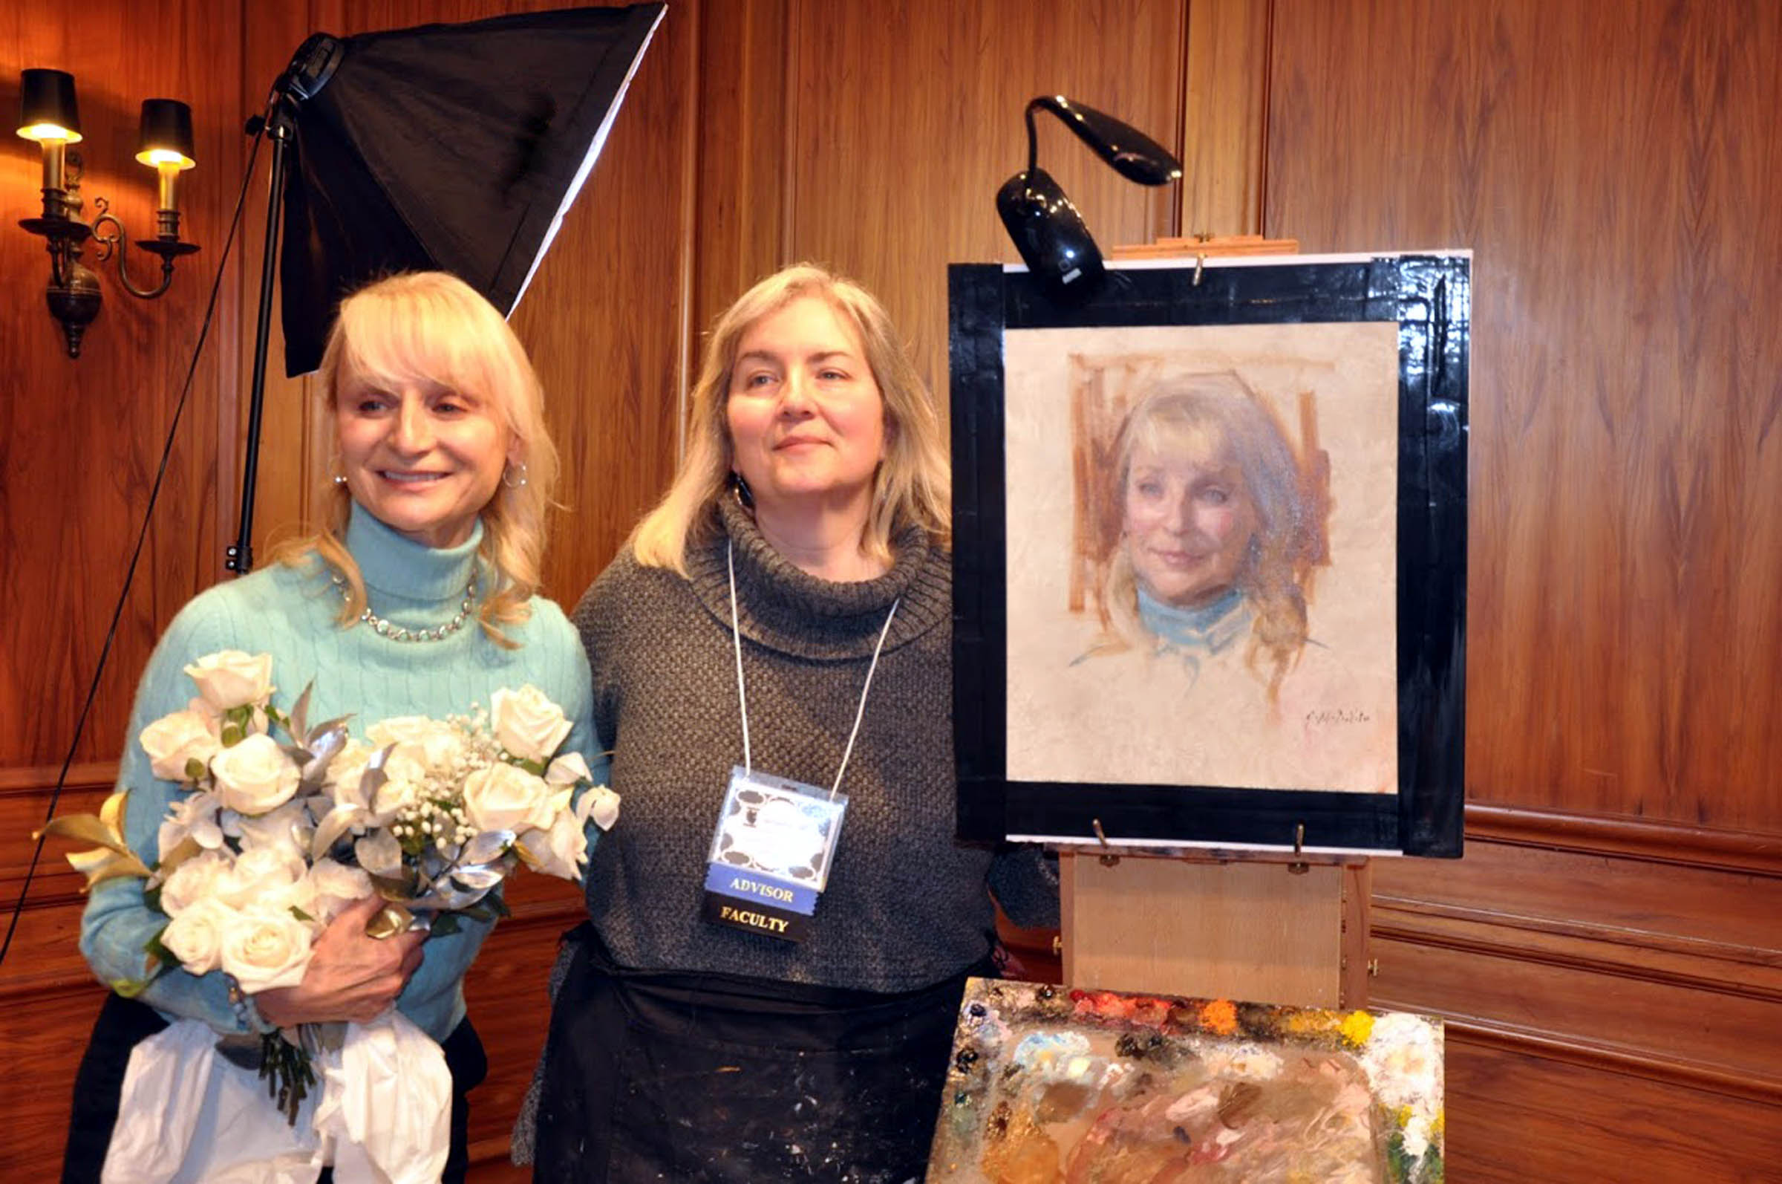
PRESS RELEASE: FOR IMMEDIATE RELEASE DRAFT 1
Date: January 16, 2019
Subject: FACE TIME Portrait Exhibit and Events
Location: Greenwich Arts Council, Bendheim Gallery and Meeting Room, 299 Greenwich Avenue, Greenwich, CT 06830; 203-862-6750
Duration: January 13 - February 7, 2019
Cost: Free and Open to the Public Image provided by ShawnaLee Kwashnak with permission.
Contact: Jeanine C. Jackson, CSOPA Founder and President; csocietyopa@aol.com; 203-856-4713

January 13, 2019, Greenwich, CT: Acclaimed portraitist Grace Mehan DeVito presented a live demonstration on Sunday with guest model, Marcia O'Kane, CEO and President of The Greenwich Chamber of Commerce. This was a highlight of the crowded opening reception at The Greenwich Arts Council for Face Time: Classical Portraiture in a Digital Age that included docent tours, awards, and live jazz piano. The exhibition features 42 artists and nearly 70 original works of art for sale and by commission presented by The Connecticut Society of Portrait Artists. It remains on view with free admission at the Bendheim Gallery through February 7. Children's Portrait Workshop for ages 8-18 on January 26 ($5). John Howard Sanden Norman Rockwell Mystery Presentation February 2 (Free admission). Details and reservations on csopa.org and greenwicharts.org.

